Step1: Clone the source and push to your repo
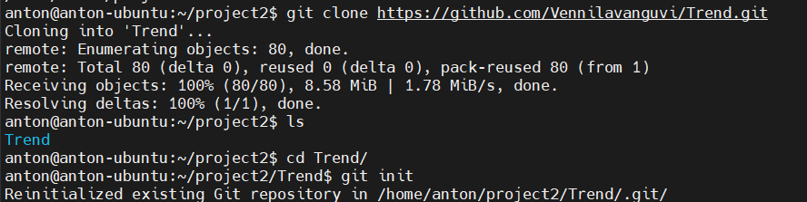
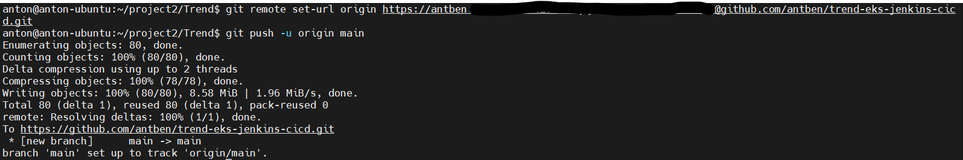

Step2: Create .gitignore and .dockerignore files
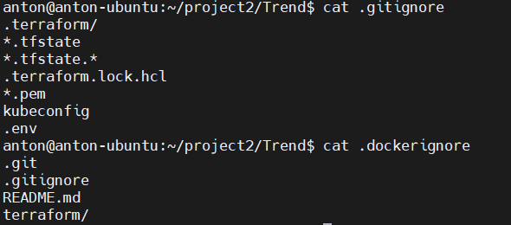
Step3: Push the initial code to github repository
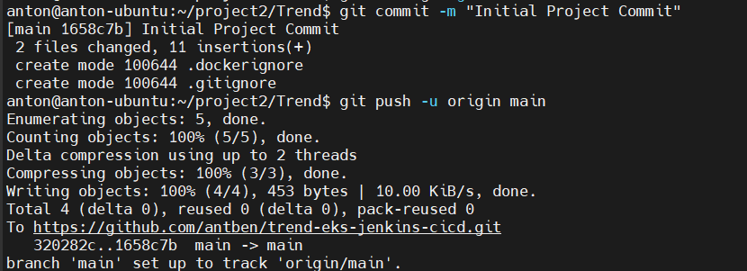
Step4: Create Dockerfile
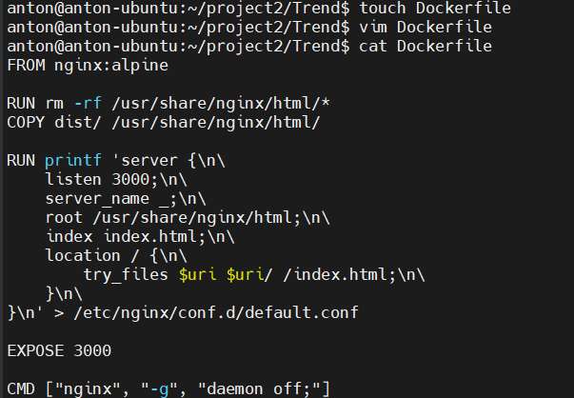
Step5. Build Trend app docker image
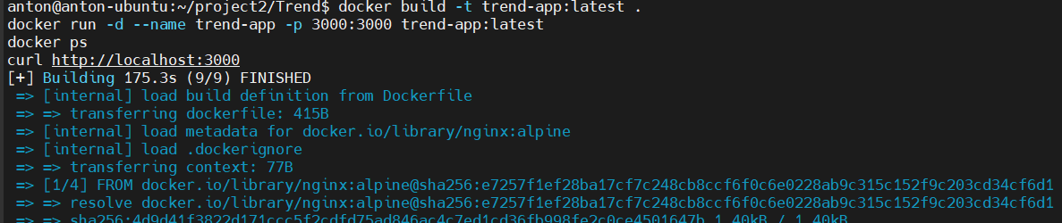
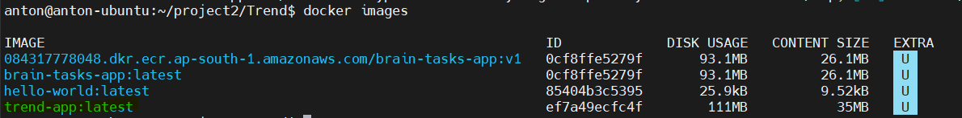
Step5. Tag the local docker image and push it to docker image repository
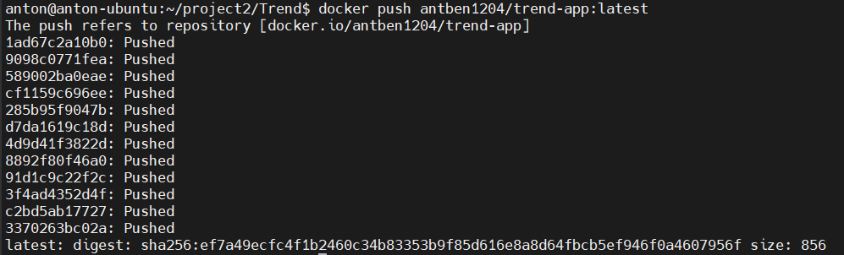
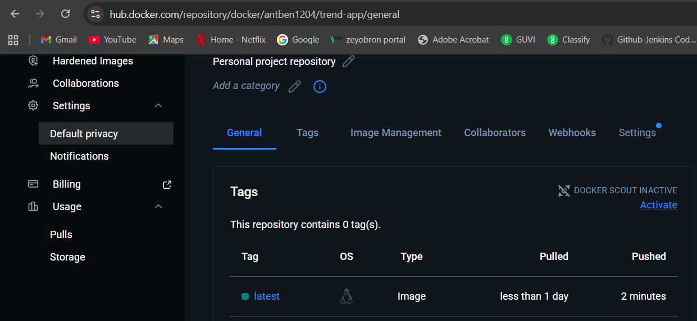
Image pushed successfully to Docker Repository
Step6. Use Terraform to create AWS Infra: VPC, subnet, EC2 instance hosting Jenkins server. Script ran successfully, created all required AWS resources: VPC, 2 public subnets, an EC2 instance for Jenkins
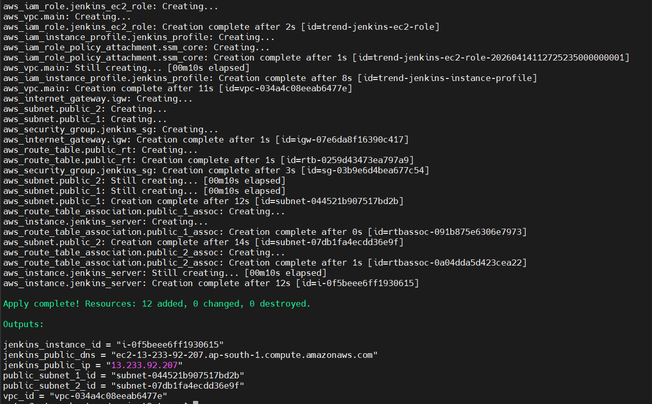
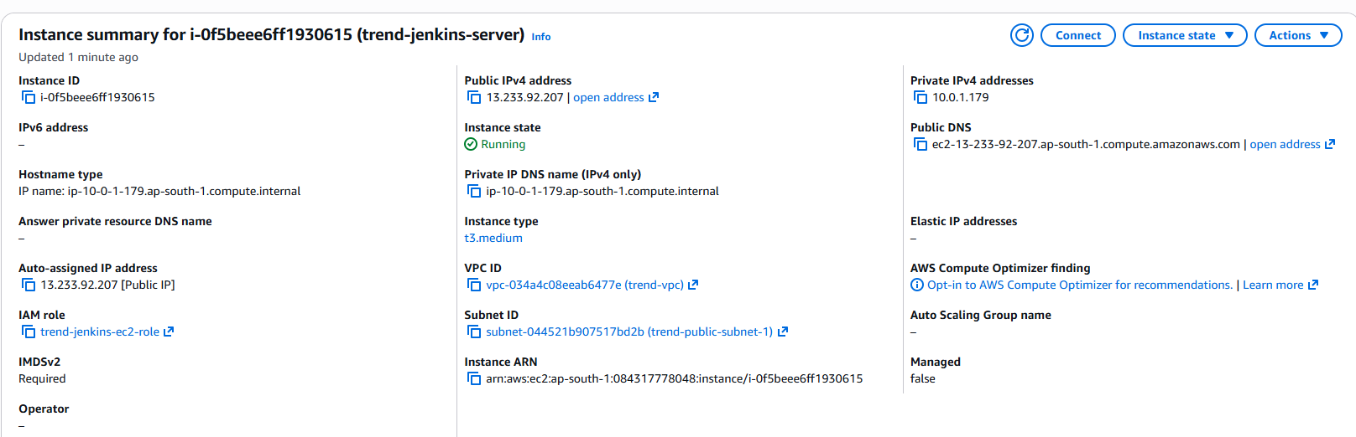

Step7. Login to the AWS instance created in previous step and install Docker, Java, Jenkins,
Java install:
sudo apt install -y openjdk-17-jdk
java –version
Git Install:
sudo apt install -y git
git –version
Install Docker:
sudo apt install -y docker.io
sudo systemctl enable docker
sudo systemctl start docker
docker –version
Install Jenkins:
curl -fsSL https://pkg.jenkins.io/debian-stable/jenkins.io-2026.key | sudo tee \
/usr/share/keyrings/jenkins-keyring.asc > /dev/null
echo deb [signed-by=/usr/share/keyrings/jenkins-keyring.asc] \
https://pkg.jenkins.io/debian-stable binary/ | sudo tee \
/etc/apt/sources.list.d/jenkins.list > /dev/null
sudo apt update
sudo apt install -y Jenkins
sudo systemctl enable jenkins
sudo systemctl start jenkins
sudo systemctl status Jenkins
Add Jenkins to the Docker group:
sudo usermod -aG docker jenkins
sudo systemctl restart jenkins
Access Jenkins from http://<your-ec2-public-ip>:8080
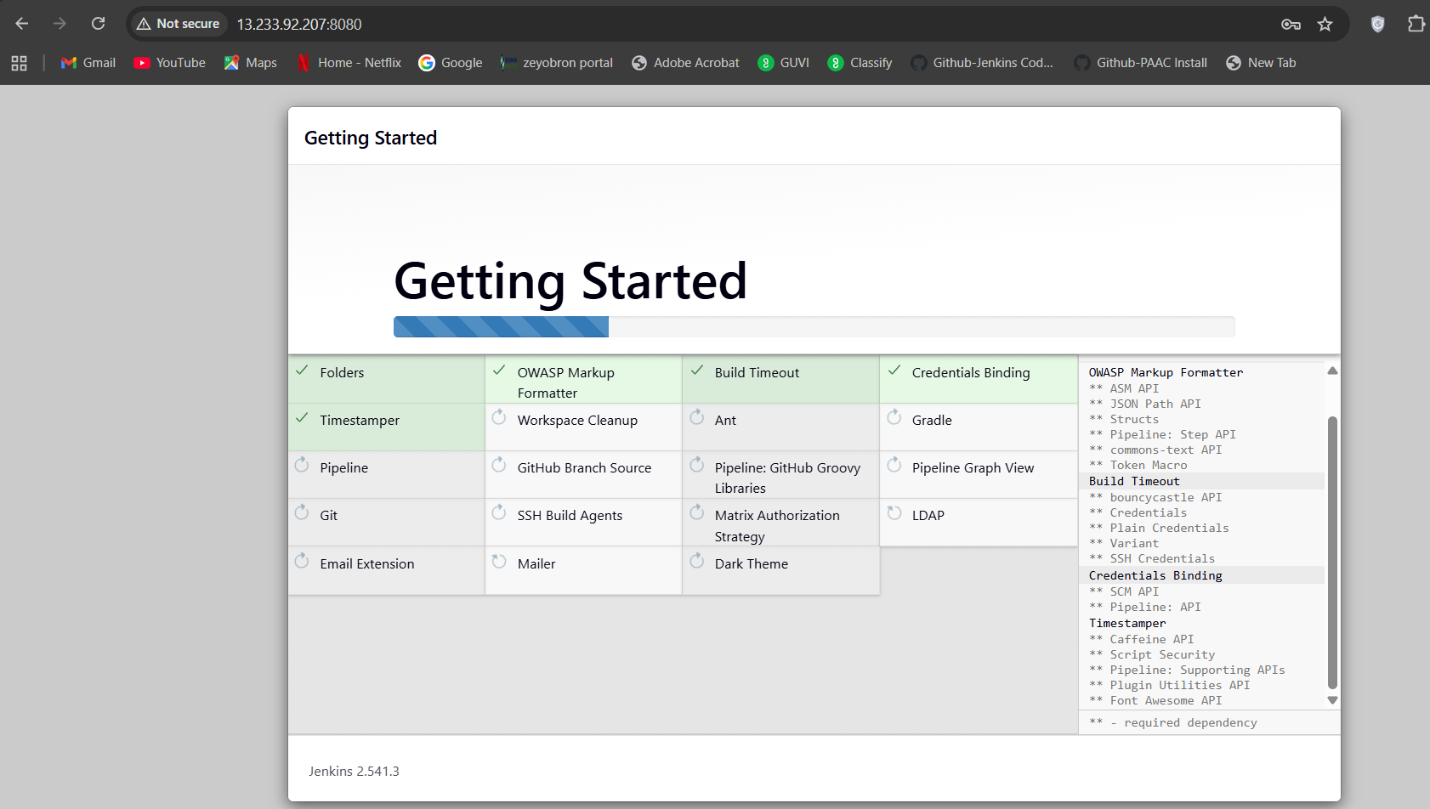
Step8. Login to Jenkins Install Suggested plugins. Then install required plugins:
workflow-aggregator
pipeline-stage-view
git
git-client
github
docker-workflow
credentials-binding
kubernetes-cli
Step9. In Jenkins , in Manage Jenkins → Credentials:
- github-creds
GitHub username/token or PAT
- dockerhub-creds
Docker Hub username/password or access token
- aws-creds
AWS access key and secret key
Step10. Create Jenkins Pipeline
In Jenkins:
- Click New Item
- Enter a name: trend-app-pipeline
- Choose Pipeline
- Click OK
Under General
- Check GitHub project
- Enter:
https://github.com/antben/trend-eks-jenkins-cicd
Under Build Triggers
- Check GitHub hook trigger for GITScm polling
That trigger is the standard GitHub-plugin-based webhook trigger in Jenkins.
Under Pipeline
Set:
- Definition → Pipeline script from SCM
- SCM → Git
- Repository URL →
https://github.com/antben/trend-eks-jenkins-cicd.git
- Credentials → select github-creds
- Branches to build →
*/main
- Script Path →
Jenkinsfile
Then click Save.
In GitHub:
- Open your repository
- Click Settings
- In the left sidebar, click Webhooks
- Click Add webhook
GitHub’s official webhook flow is exactly: repository page → Settings → Webhooks → Add webhook.
Payload URL: http://<EC2-PUBLIC-IP>:8080/github-webhook/
Content type: application/json
Step11: Create EKS cluster using below ekscluster.yaml:
apiVersion: eksctl.io/v1alpha5
kind: ClusterConfig

metadata:
name: trend-eks-cluster
region: ap-south-1

vpc:
id: vpc-034a4c08eeab6477e
subnets:
public:
ap-south-1a:
id: subnet-044521b907517bd2b
ap-south-1b:
id: subnet-07db1fa4ecdd36e9f

managedNodeGroups:
- name: trend-nodegroup
instanceType: t3.medium
desiredCapacity: 2
minSize: 2
maxSize: 2
privateNetworking: false
ssh:
allow: false

eksctl cmd: eksctl create cluster -f ekscluster.yaml
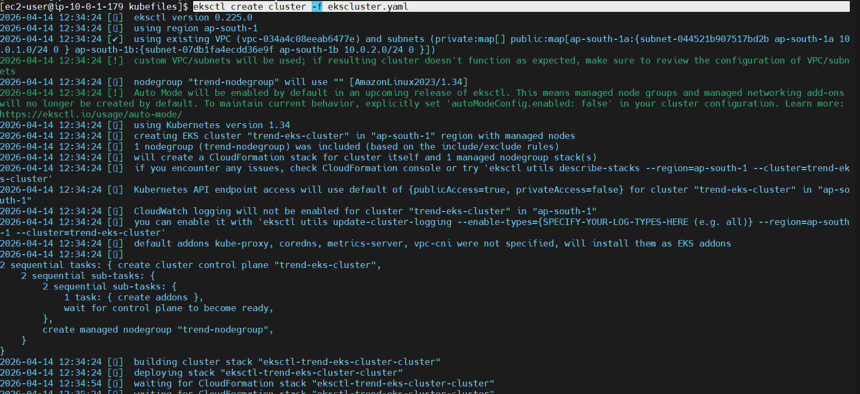
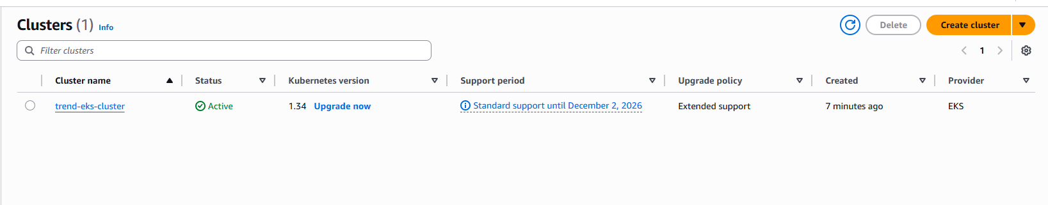

Step12: Create a TrendEKSNodeRole , Add Node groups to the cluster with the TrendEKSNodeRole attached
Create the trust policy file:
cat > eks-node-role-trust-policy.json <<'EOF'
{
"Version": "2012-10-17",
"Statement": [
{
"Effect": "Allow",
"Principal": {
"Service": "ec2.amazonaws.com"
},
"Action": "sts:AssumeRole"
}
]
}
EOF
Create the IAM role:
aws iam create-role \
--role-name TrendEKSNodeRole \
--assume-role-policy-document file://eks-node-role-trust-policy.json

Attach the required policies:
aws iam attach-role-policy \
--role-name TrendEKSNodeRole \
--policy-arn arn:aws:iam::aws:policy/AmazonEKSWorkerNodePolicy

aws iam attach-role-policy \
--role-name TrendEKSNodeRole \
--policy-arn arn:aws:iam::aws:policy/AmazonEC2ContainerRegistryPullOnly

aws iam attach-role-policy \
--role-name TrendEKSNodeRole \
--policy-arn arn:aws:iam::aws:policy/AmazonEKS_CNI_Policy
Verify the role exists and get its ARN:
aws iam get-role --role-name TrendEKSNodeRole --query 'Role.Arn' --output text
Output:
Create NodeGroup:
aws eks create-nodegroup \
--region ap-south-1 \
--cluster-name trend-eks-cluster \
--nodegroup-name trend-nodegroup \
--subnets subnet-044521b907517bd2b subnet-07db1fa4ecdd36e9f \
--node-role arn:aws:iam::084317778048:role/TrendEKSNodeRole \
--scaling-config minSize=2,maxSize=2,desiredSize=2 \
--instance-types t3.medium \
--ami-type AL2023_x86_64_STANDARD \
--capacity-type ON_DEMAND \
--disk-size 20

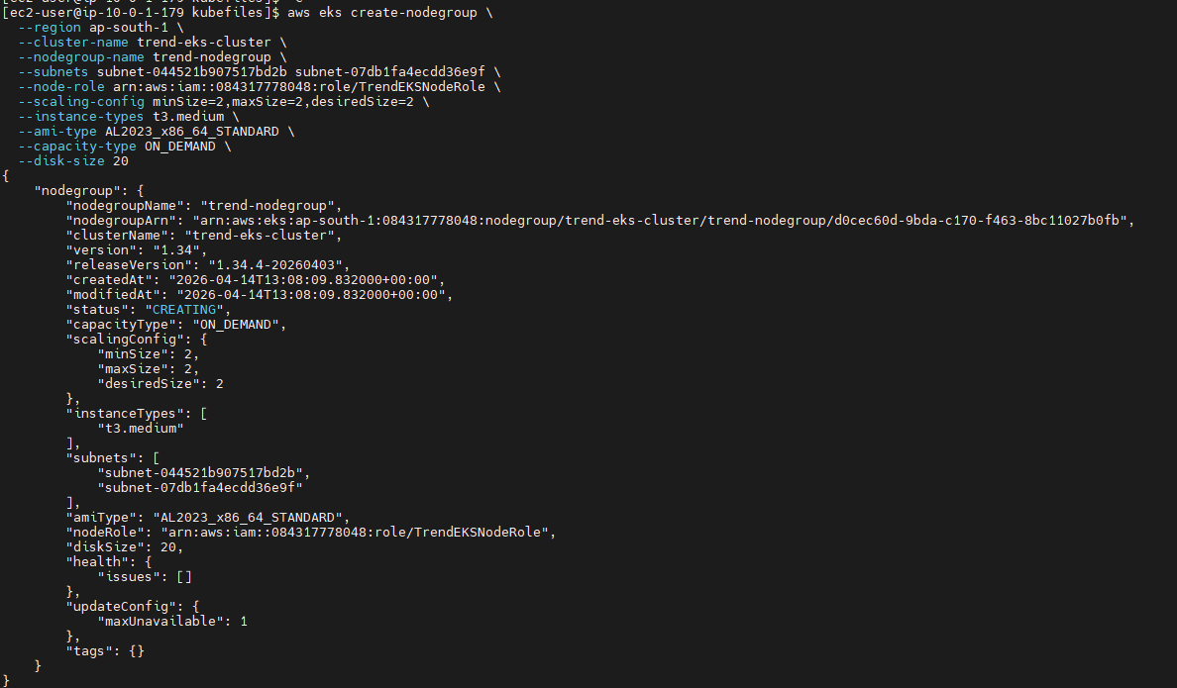
After sometime the nodes are created, run below cmd to confirm
Create Deployment.yaml and Service.yaml:
Deployment.yaml:
apiVersion: apps/v1
kind: Deployment
metadata:
name: trend-app-deployment
labels:
app: trend-app
spec:
replicas: 2
selector:
matchLabels:
app: trend-app
template:
metadata:
labels:
app: trend-app
spec:
containers:
- name: trend-app
image: antben1204/trend-app:latest
imagePullPolicy: Always
ports:
- containerPort: 3000

Service.yaml:
apiVersion: v1
kind: Service
metadata:
name: trend-app-service
labels:
app: trend-app
spec:
type: LoadBalancer
selector:
app: trend-app
ports:
- protocol: TCP
port: 80
targetPort: 3000
Step13: Push code to github repository
Git add .
git commit -m "Updated Jenkinsfile"
git push origin main
This push will trigger a build in Jenkins pipeline through Webhook
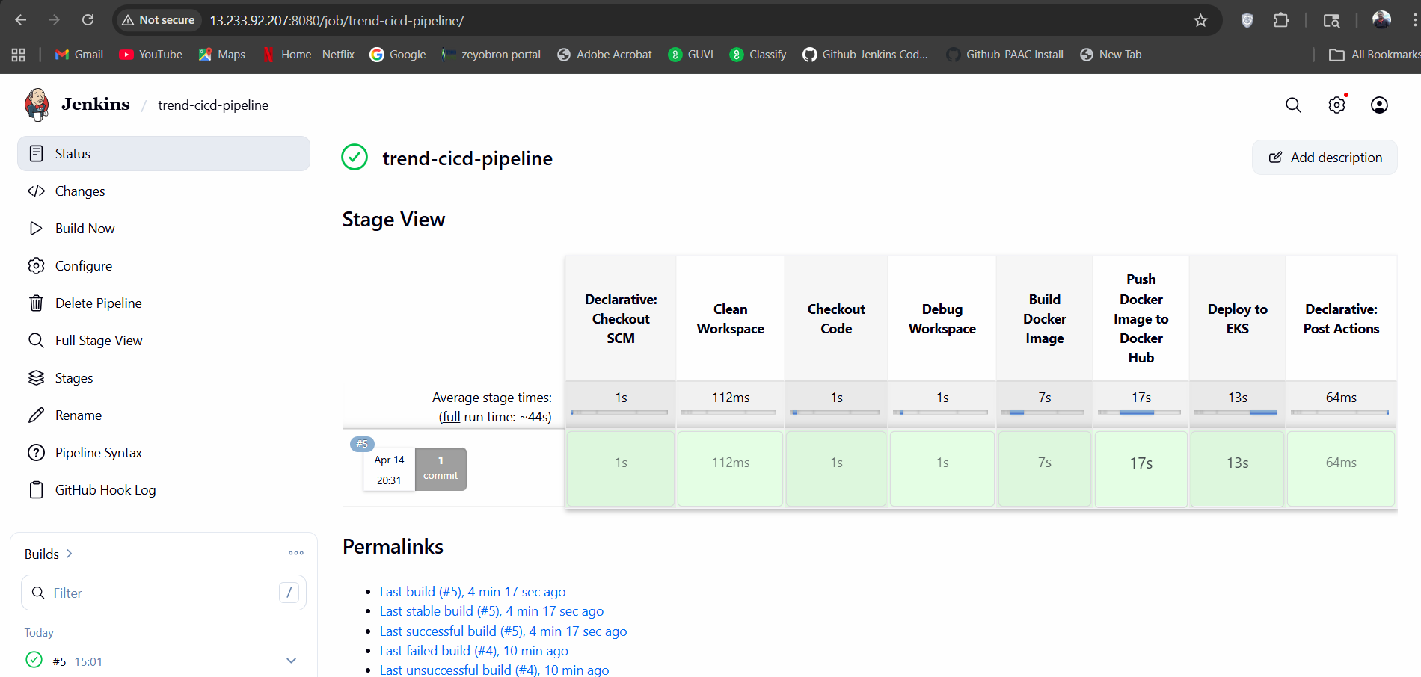

Step14: Run below cmd :
kubectl get svc

App accessible through elb: http://a964ed16c5d70499896bb5674bac1be4-947490863.ap-south-1.elb.amazonaws.com/


Step15: Configure Monitoring:
Install Prometheus+ Grafana
helm repo add prometheus-community https://prometheus-community.github.io/helm-charts
helm repo update

helm install monitoring prometheus-community/kube-prometheus-stack
Verify installation
kubectl get pods
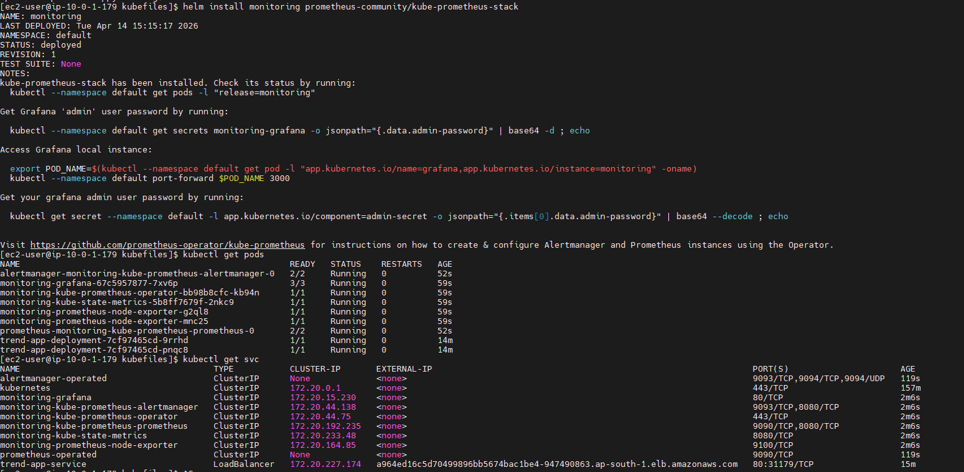
Expose Grafana to the load balancer:
kubectl patch svc monitoring-grafana -p '{"spec": {"type": "LoadBalancer"}}'
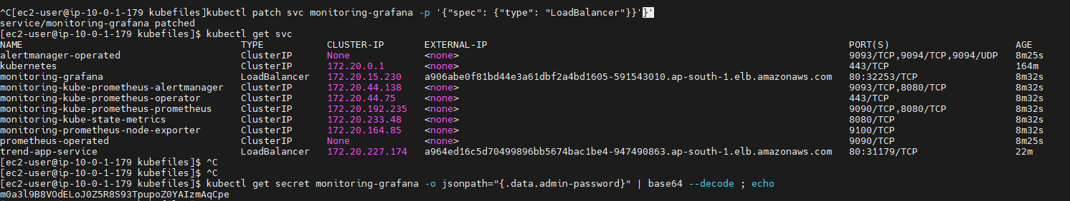

Run below cmd to get login password
kubectl get secret monitoring-grafana -o jsonpath="{.data.admin-password}" | base64 --decode ; echo

Access Grafana thru loadbalancer url and login. From dashboards, search “Kubernetes” -monitor pods, networking etc.
